***Budget Planner Project***

Oleksandr Kokotko w67955, Timur Abdugalilov w68606, Alnur Madiyev w68646

**Rzeszów 2024**

**Contents**

**Introduction 3**

**System requirements: 3**

**Installation Instructions 4**

**Application Functionality Overview 6**

**Conclusions 13**

# Introduction

The Budget Planner is a sophisticated yet user-friendly personal finance management tool developed to assist individuals in navigating their financial landscape with greater clarity and control. Built on the robust framework of C# and leveraging the versatile capabilities of Windows Presentation Foundation (WPF), this application stands out for its intuitive design and comprehensive feature set. At its core, the Budget Planner facilitates the meticulous tracking of income and expenses, enabling users to establish a detailed and adaptable budget framework.

The primary purpose of the Budget Planner is to demystify the process of financial planning and budgeting for individuals who aspire to take charge of their financial destiny. Whether it's managing day-to-day expenses, planning for significant life events, or setting long-term financial goals, this application is designed to serve as a reliable and insightful financial companion.

The target audience for the Budget Planner encompasses a broad spectrum of users, from college students grappling with budget constraints, to young professionals seeking to optimize their financial resources, and even to families endeavoring to maintain a healthy financial balance.

# System requirements:

To ensure the Budget Planner runs smoothly, please verify your system meets the following minimum requirements:

* Operating System:

Microsoft Windows 7, 8, or 10.

* Additional Software:

1. Visual Studio 2019 (16.9.4 or later) for application development and execution.
2. .NET Framework (4.8.04084) to support application runtime.
3. .NET Core SDK (5.0) for building and running the application.

Ensure your system aligns with these specifications before installation to avoid potential issues.

# Installation Instructions

To install and run the Budget Planner application on your system, follow these steps:

1. Extract the Application Files:

Locate the downloaded ZIP folder named "Budget Planner".

Right-click on the folder and choose "Extract All..." to decompress the contents into a specified directory.

Running the Application:

Using Visual Studio

Navigate to the extracted folder and double-click the .sln file to open the project in Visual Studio.

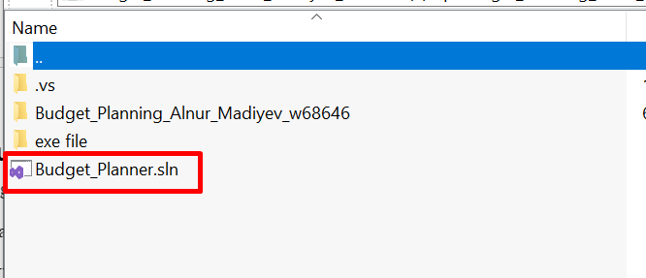

Fig. 1 - .sln file inside the folder

Press F5 or click the "Run" button in Visual Studio to launch the application.

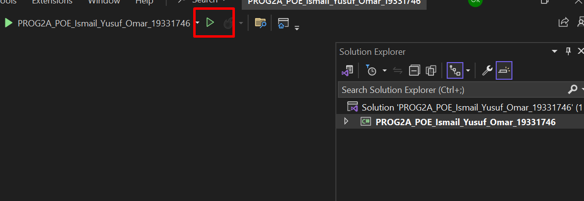

Fig. 2 - Run button in VS

Double-click the .exe file to start the Budget Planner application directly without Visual Studio.

Following these instructions will install the Budget Planner on your system.

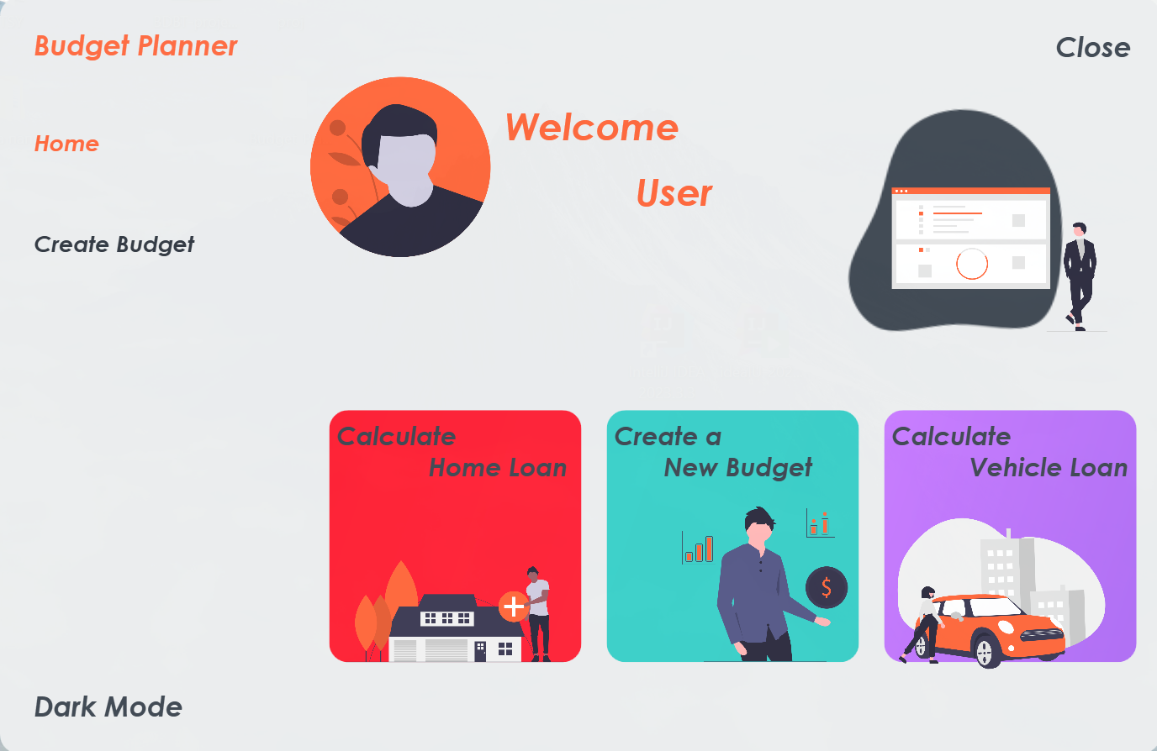

Fig. 3 - Launched application

# Application Functionality Overview

The Budget Planner application is designed with a range of features to assist users in effectively managing their personal finances. Below is an overview of its core functionalities: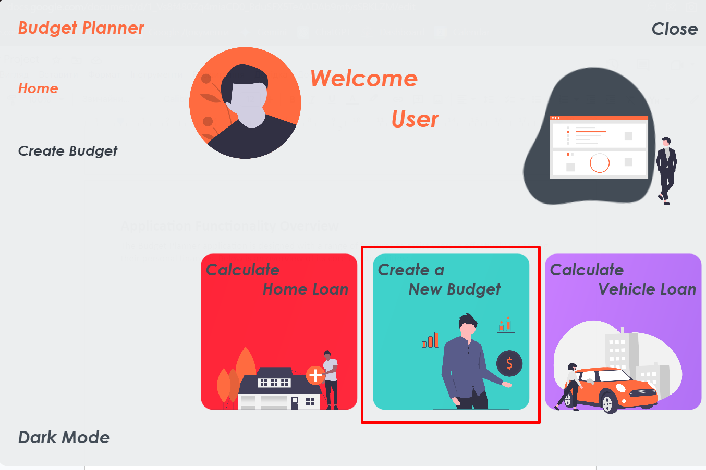

Fig. 4 - Main page overview

As we can see, the main intention of this version of application is to allow user to calculate and create a budget.

To initiate the budget creation process, users must first select the type of budget they wish to establish. There are three mandatory options to choose from:

* Acquiring Real Estate or Opting for Rental
* Purchasing a Vehicle
* Monthly Savings Allocation

It is essential to make a selection from these options as a preliminary step before proceeding with the budget setup.

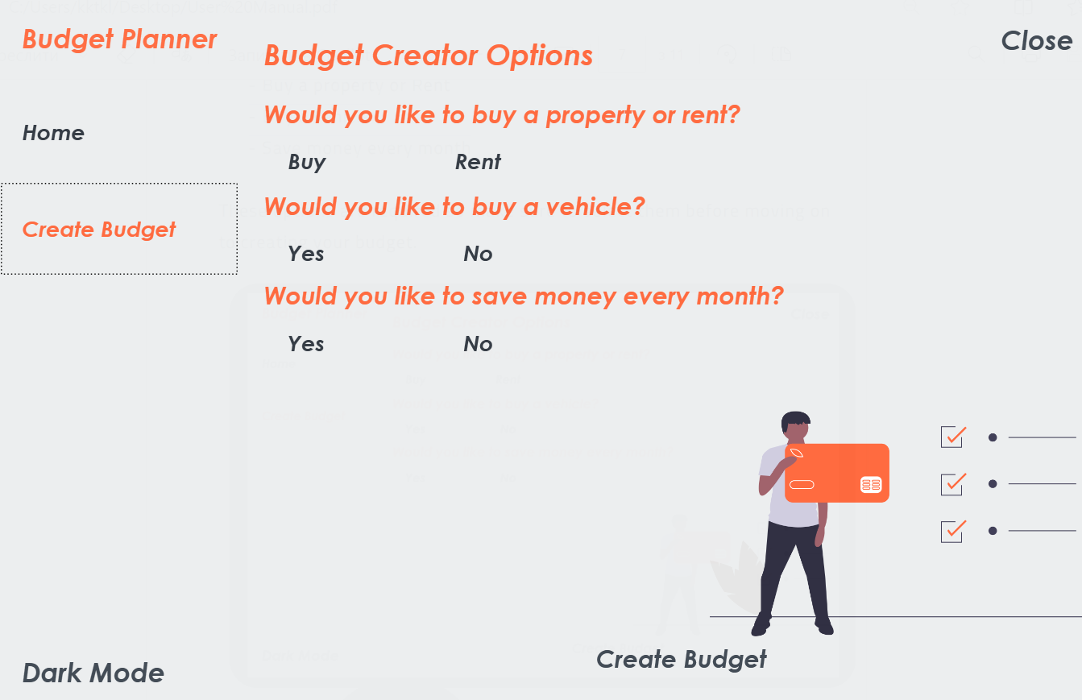

Fig. 5 - “Create budget” page

When choosing the "Monthly Savings" option, ensure that the target date set for your savings goal is in the future. Following this selection, the application will guide you to estimate your expenses.

Based on your initial choices, you will either need to input your monthly rental costs, or the application will automatically compute your mortgage and vehicle loan repayments for you.

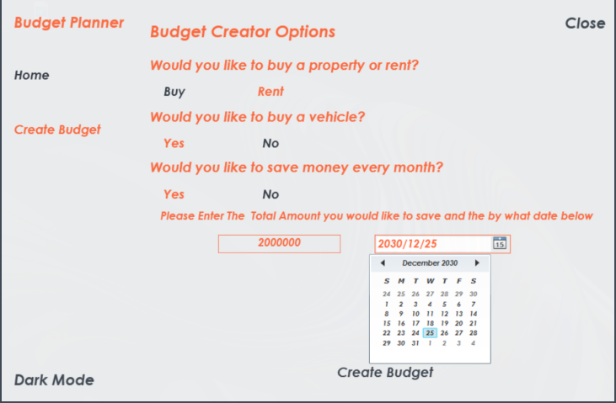

Fig. 6 - Options demonstration

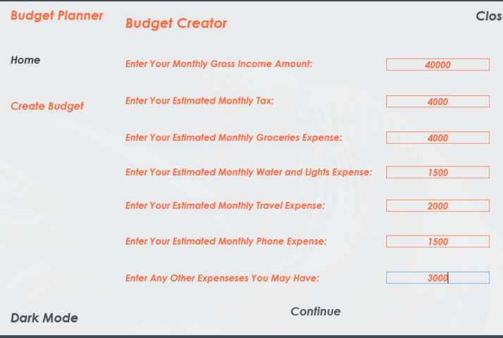

Fig. 7 - Options demonstration

Besides that, the application supports dark mode view for users who prefer it over the light version.

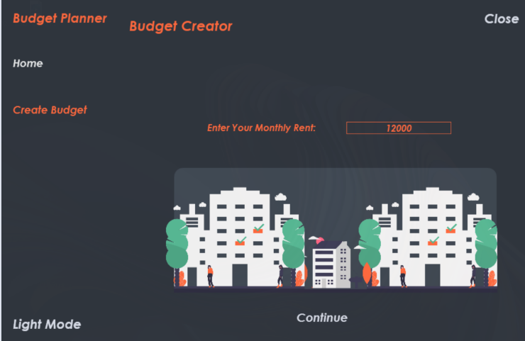

Fig. 8 - Options demonstration + dark mode view

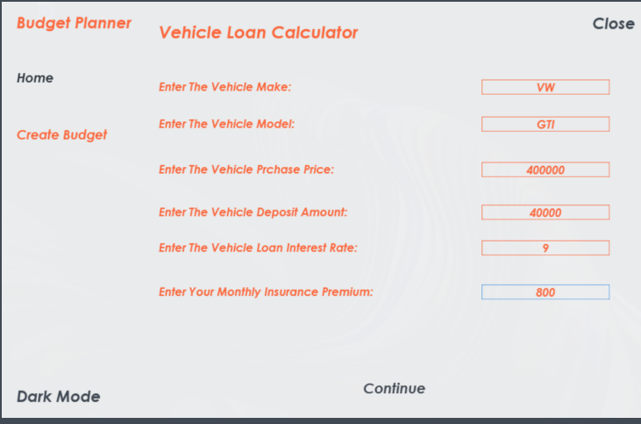Fig. 9 - Options demonstration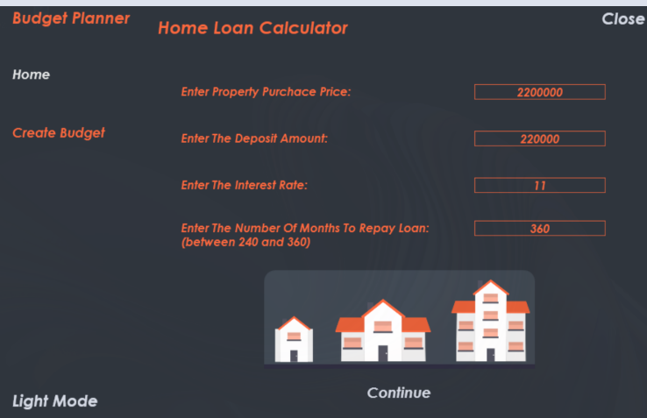

Fig. 10 - Options demonstration + dark mode view

After entering all the necessary information, the application will generate a comprehensive report. This report will detail your estimated monthly surplus and provide insights into your primary spending areas.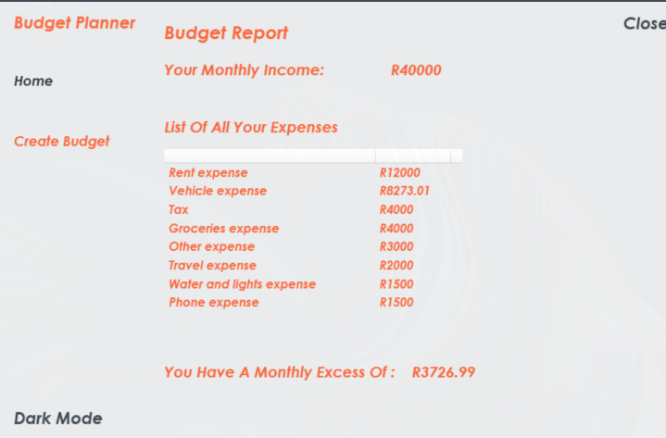

Fig. 11 - Final outcome

# Conclusions

The Budget Planner application emerges as a pivotal resource for individuals seeking to navigate the complexities of personal finance with ease and precision. By amalgamating income and expense tracking with customizable budgeting functionalities, the application not only enhances users' awareness of their financial standing but also empowers them to take proactive steps towards achieving their financial aspirations. Whether the goal is to manage day-to-day expenditures, save for a significant future investment, or understand spending habits better, the Budget Planner provides the necessary tools and insights to guide users towards informed financial decisions.

At its core, the application's strength lies in its ability to adapt to the diverse financial goals and needs of its users. From planning for major life events like buying a property or a vehicle to setting and achieving savings targets, the application's versatility ensures that users can tailor their budgeting strategies to align with their specific objectives.

In conclusion, the Budget Planner stands out as a practical tool in the realm of personal finance management. Through its straightforward approach and focused functionality, it empowers users to take charge of their finances, paving the way for improved financial health and peace of mind.